

**Honors Civics and Economics 2021-2022**

**Mrs. Nosek**

**Contact Information:**

**Email:** [nosekj@gcsnc.com](mailto:nosekj@gcsnc.com)

**Phone:** 336.643.8449 Ext. 1660

**Room #:** 220

Welcome to HONORS CIVICS AND ECONOMICS!  This year you will learn about American economics, government and politics.  One of the major goals of this course is to teach you how to become a good citizen. This goal will be accomplished through two parts. The first part is learning about civic virtues, how our government works, and the responsibilities of all citizens. The second part is learning how nations, businesses, and individuals earn, invest, and spend money.  Also, you will examine controversial issues so you can understand the debates that shape our society.  My role is to help you understand your part in the United States government and economy. I will do this by asking the hard questions we all face as citizens, prompting you to ask your own questions and reach your own opinions.

2021-2022 Remind Code: **@4abakcf**

# General Expectations:

1. Be on time- please take care of bathroom, water, and grooming needs before class
2. Show respect for yourself, classmates, and teacher
3. Be prepared: you need the right attitude, an open mind, and the right materials
4. Be responsible, keep up with your assignments. (late work will be penalized)
5. No food or drink in the classroom- you may have water. NO PEANUTS OF ANY KIND.
6. Stay organized: we cover several topics at once and assignments will overlap
7. Communication: ask questions if things are unclear
8. NO CELL PHONES/ELECTRONICS
9. Do not disrupt class. Disruptions will first result in a warning, then a conference with me, if the problem continues a phone call home, then a referral to administration. Student will be sent to administration in the event of a severe disruption.

# Grading Policy:

1. Test, Papers, & Projects: 50%

**The social studies department assigned testing days are Wednesday and Friday**

1. Individual assignments: 20%
2. Quizzes/mini projects: 30%

**\*There is no extra credit offered under any circumstance. Students will be presented with ways to improve their grade through retesting at the end of 1st and 2nd quarter and completion of assignments.**

**C&E Course Information**

This class is broken up into 2 major topics, economic and government. We will begin the year with looking at the American economy and how it operates. We will then move on to discuss the American government. The units and tentative test dates are as follows: (please note test dates are subject to change)

* + 1. Foundations of American Democracy
    2. Government Systems
       1. The Legislative Branch
       2. The Executive Branch
       3. The Judicial Branch
    3. Law
    4. Politics and Public Policy
    5. Citizenship
    6. Foundations of Economics
    7. Economics at Work
    8. Personal Finance

**Canvass**

Daily Announcements, Assignments, Discussions will be posted daily on the class CANVAS Page.

**Assignments:**

**Tests**

I will give at least a week of notice before each test. Most tests will include the following: 20-35multiple choice questions (depending on the length of the unit), 1-3 free response questions. The final assessment for this class will be a N.C. Final Exam. This exam will consist of around 40 multiple

choice questions and will count as 20% of your final grade. On test days be prepared to turn in your cell phones. They may not be on your person during the test.

**Quizzes**

We cover a lot of content in C&E, therefore it is imperative that students are keeping up with and retaining information as we progress throughout the year. In order to make sure that you are keeping up and processing topics covered there will be several quizzes throughout each unit. Some quizzes will be announced and other will be unannounced. I often quiz to ensure students are staying on top of their assignments and readings, that way we can address concepts that are not understood PRIOR to testing.

**Current Events**

Sometimes you will be expected to apply what you have learned through article reviews. You will be expected to take current events and connect them to content covered in class.

**Warm-ups**

Most days when you come in to class there will be some type of warm up. Warm-ups may be in the form of a handout but most times warm-ups will be questions posted on the board or simple directions to take out your homework. I expect you to enter the classroom and get started on the warm-up immediately.

**Discussions**

I’ll give you lots of articles, readings, and political cartoons to respond to in class. You must read/analyze these items in order to participate in class discussions. Question on these items will be included on tests.

**Projects**

For the most part each unit has an accompanying project. Projects will come in various forms, such as creating scrapbooks, games, photo essays, PowerPoint presentations, etc. Some of these projects will be completed in groups, other will be done independently.

**Mini Projects**

These will be less time intensive than normal projects and will mostly be completed in class. They can count as either a quiz grade, or two depending on how much work is involved.

**Free Response Questions**

Free response questions will be in response to various documents and readings. FRQs will also be present on tests and quizzes.

**Social Studies Department Protocol:**

# Cumulative Review Exam Policy:

# We will follow the NGHS school-wide cumulative exam policy. For honors courses, at the end of 1st and 2nd quarter ONLY, you will take a CRE that can replace your lowest test grade. There is no option for retakes on quizzes and/or project grades. No, CREs cannot replace projects and will not replace tests that were never attempted.

# Make-up Work and Make-up Test Policy:

# If students are absent it is their responsibility to contact me for missing work. If you are experiencing a prolonged absence, I can email most assignments to avoid having a large amount of make-up work upon your return. Assignments will also be posted online. All make assignments, quizzes, and tests are to be made up within ONE WEEK of the student returning to school, unless other arrangements have been made with the teacher. Failure to turn in missing assignments will result in a zero for a grade. (Special arrangements can be made for extended absences)

# 

# Late work policy:

# Please remember that in order to be prepared for class you need to complete assignments on time. If you are unable to make the deadline I will deduct 15 points for work turn in one day late and 30 points if it is two days late. After two days you can still complete the assignment but will receive no higher than a 50. If the assignment has already been returned to students you must come in during one of my two offered tutoring days and complete the assignment, or an alternate assignment, with me in class This does not apply to students who are absent. If student is absent the day an assignment is due the work will not be counted late but the assignment must be turned in the day they return to school to avoid late penalties.

# Other Requirements:

The QR code below is the link to the classroom wish list if you wish to contribute.

# Classroom needs

1. 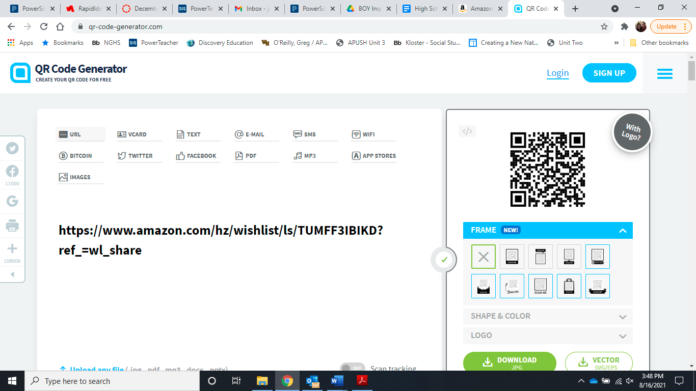Notebooks: You are required to bring a three-ring binder with loose leaf paper to class **EVERYDAY**.  You need a good supply of college rule composition paper.  All notes, handouts, and homework will be kept in this notebook.
2. Pencil, Blue/Black Ink Pen, and highlighter
3. Flash drive or online storing capabilities

**Respect**

Respect is very important to my class.  We discuss very controversial issues with a wide array of viewpoints and beliefs. The rule to remember here is that you DO NOT have to agree with me or anyone else in class, but you may NOT disrespect someone because he or she sees things differently. Any disrespectful behavior, which includes disruption, will result in parental contact, and possibly administrative action.

**Student Name:**  Last:________________ First:___________________

**Please complete and return by the second day of school.**

# Attention Parents and Guardians- PLEASE READ!!!

In Civic and Economics there always class debates and discussions on the issues that we as Americans face. Many of these issues can be very controversial, such as immigration, war, or religion in schools. First and foremost, I will never tell your student what to think or believe. That is for them to decide. I am always willing to accept that we all can agree to disagree as long as it is done respectfully. My role is as a facilitator who provides information from both sides of an argument. My hope is that it will stimulate discussion with you and their peers, as well as get them to think about what they want out of their country, state, and local community. Also, that your children will pay attention to what is happening around them and become involved in making it better. From time to time I may ask them to poll you and others on political beliefs or issues. This will be done anonymously so no one will know who gave what opinion. Please be honest and open with them about your beliefs.

I look forward to meeting you. Please do not hesitate to contact me with your questions, concerns, or comments. You play a vital role in the success of your student in Honors Civics and Economics. Please sign off that you have read through the syllabus with your student. I look forward to having a great year.

Thank You!

Jamie Denny Nosek

**Parent/Guardian Contact Information:**

Parent/Legal Guardian 1 (Please Print Name) :________________________________________

Relationship to Student:________________________________________________

Email: __________________________________________

Phone: (Home) __________________________________

(Cell)____________________________________

(Work)___________________________________

Best way to reach you (phone or email):_________________________________

Parent/Legal Guardian 2 (Please Print Name) :________________________________________

Relationship to Student:________________________________________________

Email: __________________________________________

Phone: (Home) __________________________________

(Cell)____________________________________

(Work)___________________________________

Best way to reach you (phone or email):_________________________________

Student Email Address: ________________________________

**\*\*\* Please sign below stating that you acknowledge and understand the expectations and requirements of this course as outlined in the syllabus.**

Student Signature: ________________________________

Parent/ Legal Guardian Signature: _________________________________